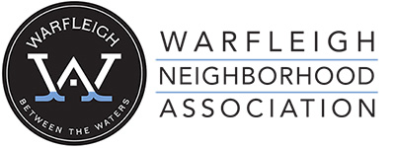
2024 Annual Meeting
March 12th, 2024
St. Paul’s Episcopal Church
7:00 PM

- Call to Order – Libby Hiple
- 2023 Neighborhood Highlights – Libby Hiple
  - INRC Grant
  - Neighbor Power Indy
  - Future Grant Funding Rounds
  - KIB Neighborhood Clean Up
- Financial Overview – Libby Hiple

Guest Speakers
- Councilor Brienne Delaney
- Harrison Rice - DPW
- Mina Moussa – Mayor’s Office
- Nicky Hornyak – KIB

Annual Voting for Board of Directors

